Section One: Short Response
30% (58 marks)
This section has sixteen (16) questions. Answer all questions. Write your answers in the spaces provided.

When calculating numerical answers, show your working or reasoning clearly. Give final answers to three significant figures and include appropriate units where applicable.

When estimating numerical answers, show your working or reasoning clearly. Give final answers to a maximum of two significant figures and include appropriate units where applicable.

Supplementary pages for the use of the planning / continuing your answer to a question have been provided at the end of this Questions/Answer booklet. If you use these pages to continue an answer, indicate at the original answer where the answer is continues – i.e. give the page number.

Suggested working time: 50 minutes

_________________________________________________________________________

Question 1 (5 marks)

A ball is thrown from S at an angle to the horizontal as shown in the diagram below. X, Y, and Z are different positions along the ball’s trajectory.

(a) On the diagram above, label each position, X, Y & Z, with an arrow that best represents the velocity and the acceleration of the ball, at that time. (3 marks)
(b) This trajectory shown above assumes that the ball is not affected by air resistance. Draw the trajectory of the ball if air resistance is present. (2 marks)

Question 2 (4 marks)
In a movie, the stunt men drove their car across a horizontal car park in building 1 and landed it in the car park of building 2, landing one floor lower. Building 2 is 20.0 m from building 1, as shown in the figure above. The floor where the car lands in building 2 is 4.00 m below the floor from which it started in building 1.
Calculate the minimum speed at which the car should leave building 1 in order to land in the car park of building 2, if the effect of air resistance is ignored.

Question3 (4 marks)
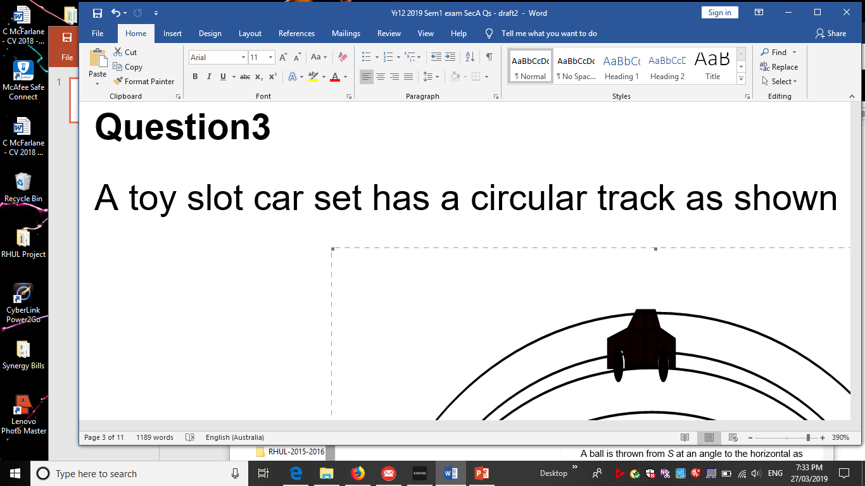
A toy slot car set has a horizontal circular track as shown in the diagram opposite.

- On the diagram show the direction of the net (unbalanced) force acting on the slot car.

- The diagram is drawn one tenth full size. The mass of the slot car is 0.25 kg and the net force is 3.25 N, estimate the speed of the car.

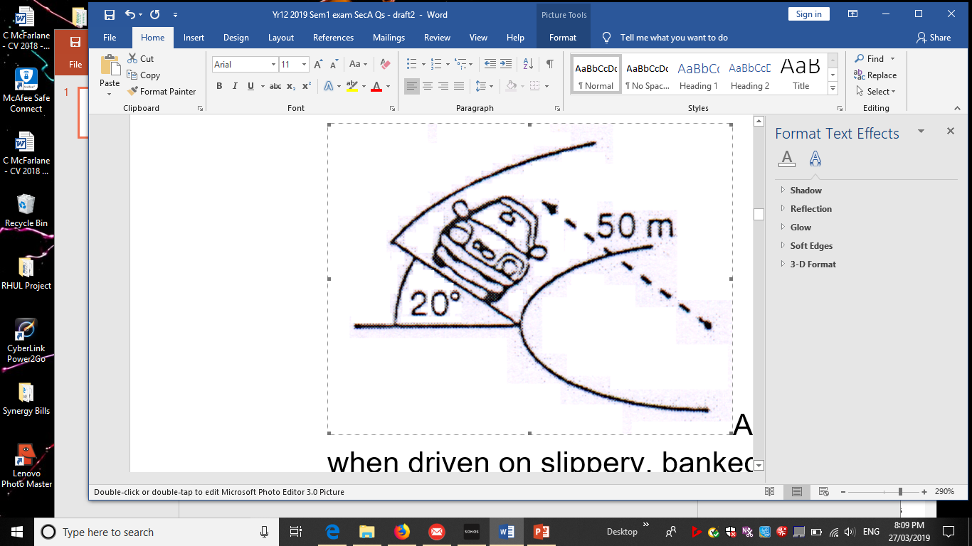
Question 4 (4 marks)
A new car is being test driven to determine how it performs when driven on slippery, banked surfaces. The car has a mass of 1.20 tonne and is driven around a 20.0º banked curve, which has a radius of 50.0 m.
Derive the formula that indicates the maximum speed the car can drive around the curve without slipping. (2 marks)
Use this formula to calculate the maximum speed of the car without slipping as it drives around the curve. (2 marks)

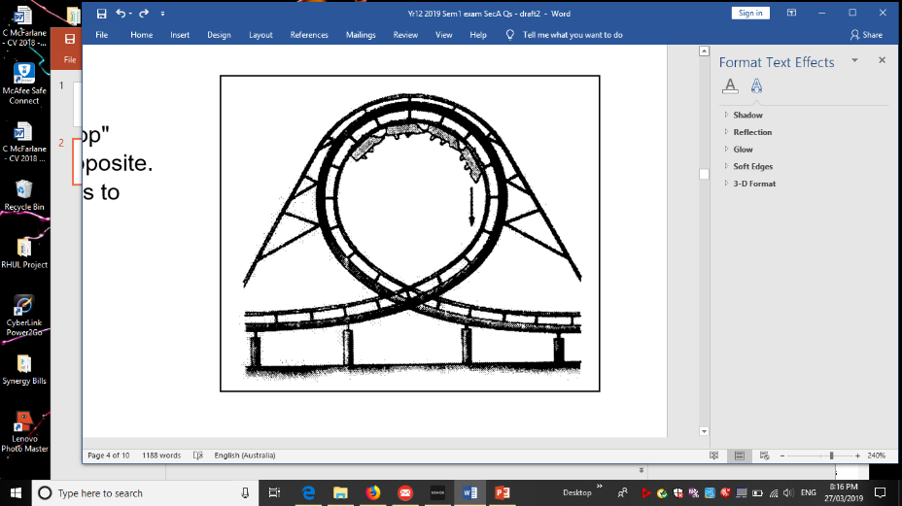
Question 5 (4 marks)
A thrill seeker is persuaded to go on a "loop the loop" amusement ride similar to the one in the picture opposite. The circular loop has a diameter of 18.0 m and it takes 4.70 s to complete one loop.
- Calculate the centripetal acceleration of a 40.0kg rider. (3 marks)

- Is the centripetal acceleration for a 50.0kg rider the same, increased or decreased? (1 mark)
Answer: ______________

Question 6 (4 marks)
The diagrams show a communications satellite in orbit about the Earth.
- Which diagram correctly represents the net force: F acting on the satellite and the velocity: v of the satellite?

ANSWER: _________
- Explain why domestic satellite dishes for pay-TV do not ‘track’ across the sky (i.e. they don’t move) although the satellites that they receive their signals from are in constant motion

Question 7 (4 marks)
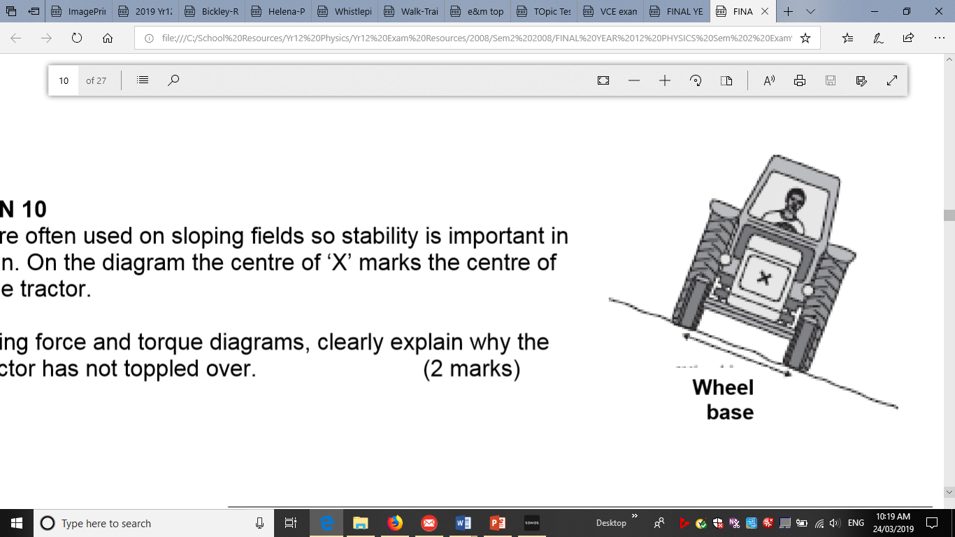
Tractors are often used on sloping fields so stability is important in their design. On the diagram ‘X’ marks the centre of mass of the tractor.
a) Using force and torque diagrams, clearly explain why the tractor has not toppled over. (2 marks)

b) State how the design of the tractor could be modified to increase the tractor’s stability. (2 marks)

Question 8 (3 marks)
The figure shows an overhead view (birds-eye view) of a metal square lying flat on a frictionless floor. Three forces, which are drawn to scale, act at the corners of the square. Circle the correct answer.
a. Is the square in translational equilibrium?
YES NO

b. Is the square in rotational equilibrium?
YES NO

c. Is it possible for a fourth force to act on the fourth corner of the square such that the square is in static equilibrium?
YES NO

Question 9 (4 marks)
The bridge in the diagram can be considered as a uniform concrete beam of length 30.0 m and mass 20.0 tonnes.
A heavily loaded small truck of mass 6.00 tonnes is pictured crossing the bridge.
Calculate the magnitude of each of the normal contact forces N1 (F_{n1}) and N2 (F_{n2}) at each end of the bridge when the centre of mass of the truck is 10.0 m from one end.

Question 10 (1 mark)
Three identical wires W1, W2 and W3 are positions as shown. Each carries a current of the same magnitude in the direction indicted.
What is the magnitude and direction of the resultant force on W2? Circle the correct answer (A, B, C, D)
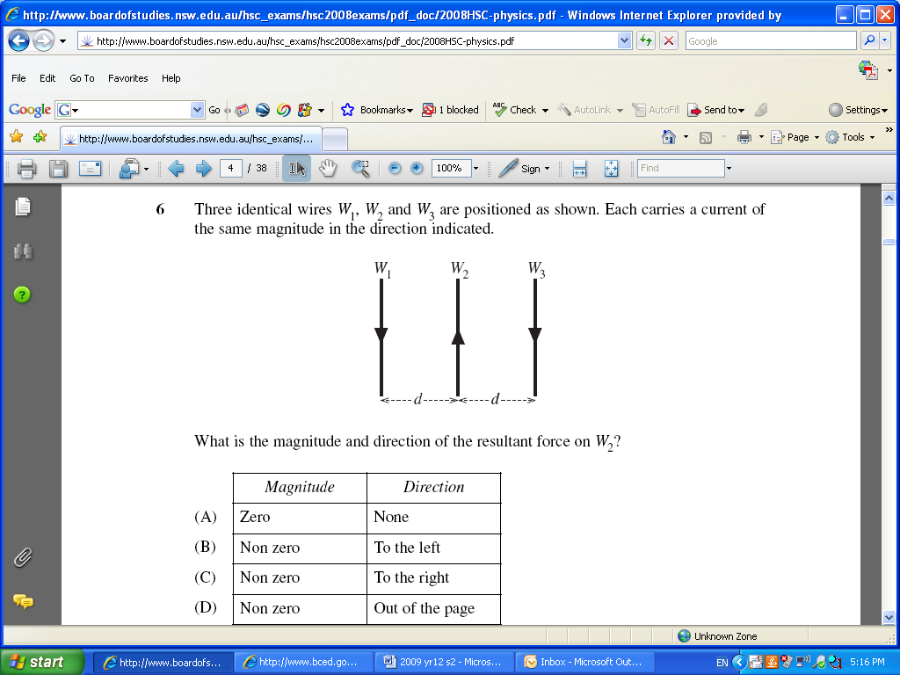

Question 11 (1 mark)
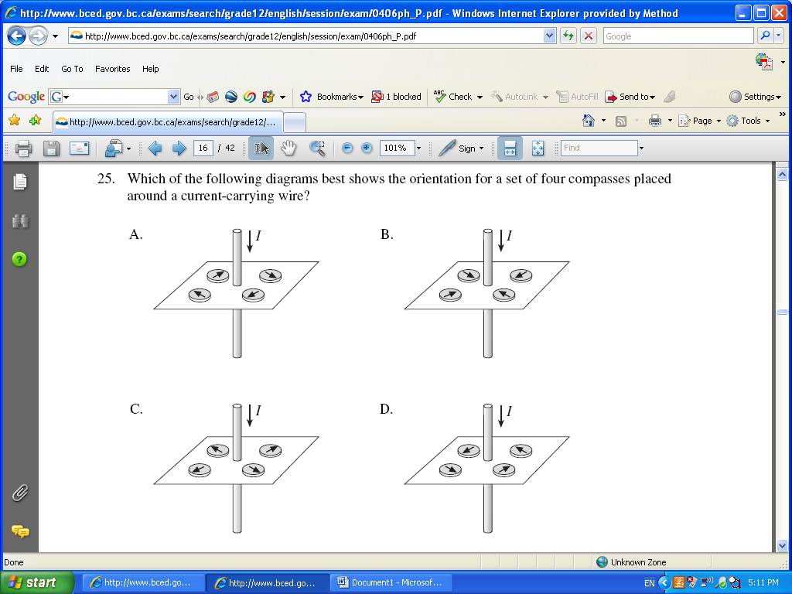
Which of the following diagrams best shows the orientation for a set of four compasses placed around a current-carrying wire?

Answer: _______

Question 12 (4 marks)
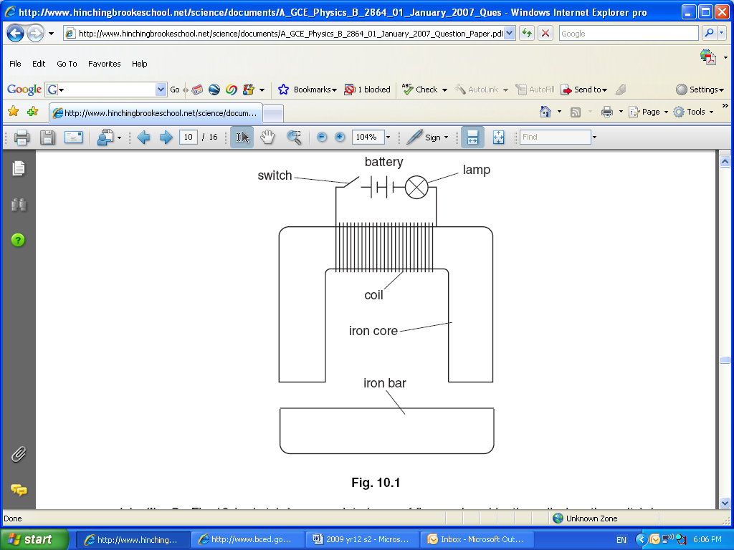
This question is about using an electromagnet to lift a heavy load.
The figure shows a coil of insulated wire wrapped around the centre of an iron core. An iron bar is pulled up to the core when the switch is closed. The lamp glows when there is current in the coil.

(a) On the diagram, sketch two complete loops of flux produced by the coil when the switch is closed. (2 marks)

(b) Use ideas of magnetic flux to explain why the iron bar is pulled up to the iron core when the switch is closed. (2 marks)

Question 13 (4 marks)
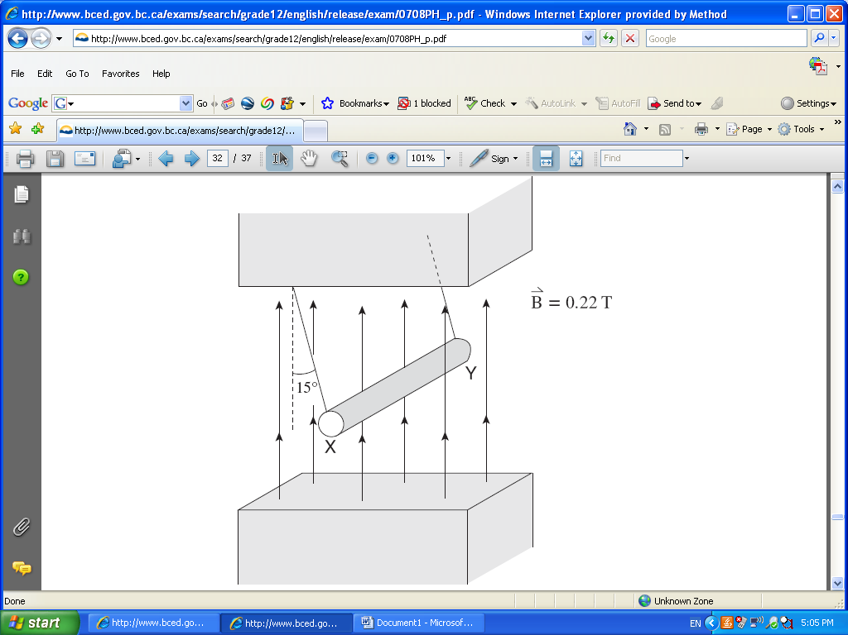
An 18.0 cm long metal rod of mass 35.0 g is suspended from the ceiling with a light wire of negligible mass. A uniform 0.220 T magnetic field is directed vertically upward.
When there is a current in the rod it swings outward 15.0° to the vertical as shown in the figure opposite
- What is the direction of the current in the rod? Circle the correct response. (1 mark)
X to Y Y to X No current

- Calculate the magnitude of the current in the rod. (3 marks)

Answer ___________________________
Question 14 (3 marks)
A beta particle travels at a speed of 3.90 x10³ km h⁻¹ while following a circular path of radius 0.0200 m perpendicular to a magnetic field. Calculate the strength of the magnetic field. Show all working.

Answer: ____________
Question 15 (3 marks)
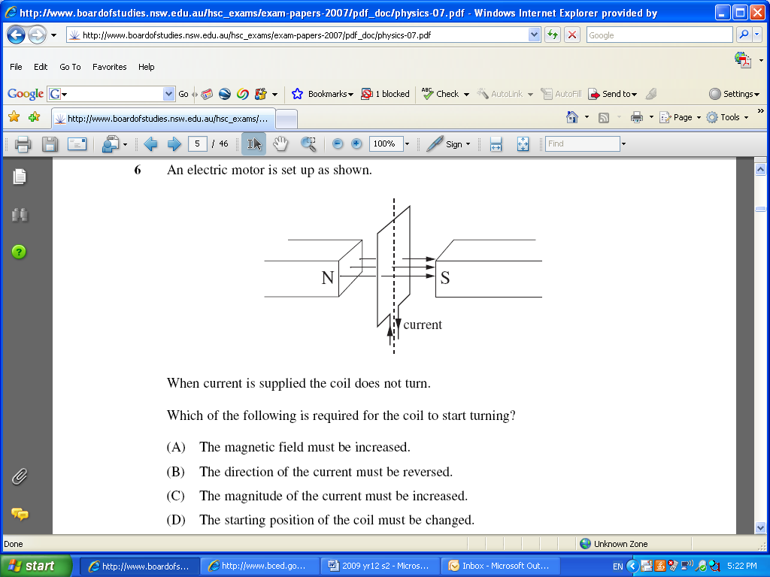
An electric motor is set up as shown in the diagram below. When the current is supplied the coil does not turn. Which of the following is required for the coil to start turning?
- The magnetic field must be increased.

- The direction of the current must be reversed.

- The magnitude of the current must be increased.

- The starting position of the coil must be changed.

Briefly explain what needs to change to allow the coil to start turning.

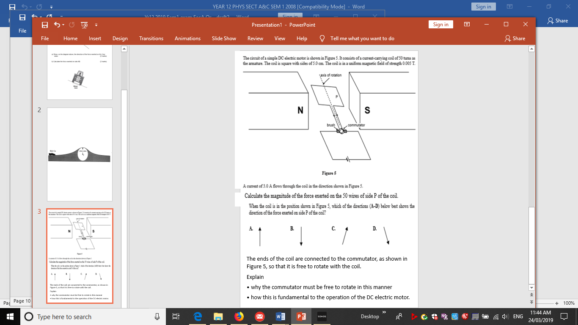
Question 16 (6 marks)
The circuit of a simple DC motor is shown in the figure opposite. It consists of a current-carrying coil of 50 turns as the armature. The coil is square with sides of 5.0cm. The coil is in a uniform magnetic field of strength 0.005T. A current of 3.0A flows through the coil in the direction shown in the diagram.

- Calculate the magnitude of the force on side P of the coil. (2 marks)

- When the coil is in the position shown in the diagram, which of the directions (A, B, C or D) best indicates the direction of the force exerted on side P? Circle the correct answer (1 mark)

- The ends of the coil are connected to a split-ring commutator, so that the coil is free to rotate. Explain why the split-ring commutator is fundamental to the operation of the DC electric motor. (3 marks)

